Story Crew
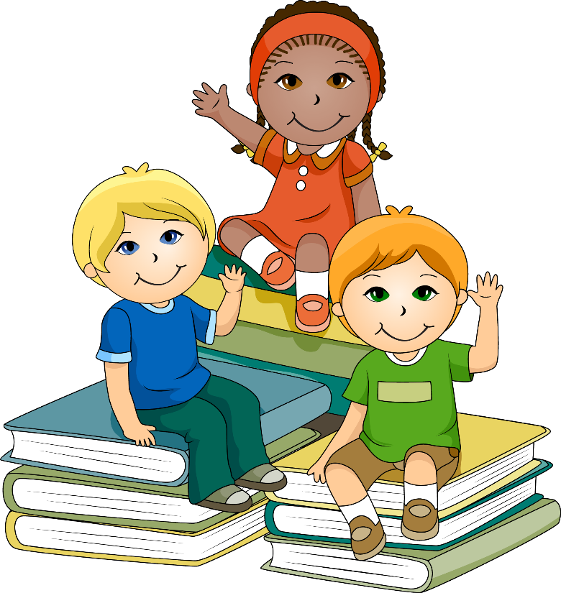
Come join us for story time, a craft and snack. Each child will receive a gently used or new book to take home.
Fun for the family
Where : Akron Elementary

When: December 9th from 10 -11AM

For all children ages 0-5

